A Mini Project Synopsis on
Private Tutors Application

S.E. - I.T Engineering

Submitted By
Akshit Lokhande Moodle ID 21104049
Miheer More Moodle ID 21104137
Ankush Jha Moodle ID 21104092
Sameer Mishra Moodle ID 21104108

Under The Guidance Of
<Prof. Shital Agrawal>



DEPARTMENT OF INFORMATION TECHNOLOGY
A.P.SHAH INSTITUTE OF TECHNOLOGY
G.B. Road, Kasarvadavali, Thane (W), Mumbai-400615
UNIVERSITY OF MUMBAI

Academic year: 2022-23

CERTIFICATE

This to certify that the Mini Project report on Private Tutors Application has been submitted by Akshit Lokhande(21104049), Sameer Mishra(21104108) and Ankush Jha(21104092) & Miheer More(21104108) who are a Bonafide students of A. P. Shah Institute of Technology, Thane, Mumbai, as a partial fulfilment of the requirement for the degree in Information Technology, during the academic year 2022-2023 in the satisfactory manner as per the curriculum laid down by University of Mumbai.

Prof. Shital Agrawal
Guide

Dr. Kiran Deshpande Dr. Uttam D.Kolekar
Head Department of Information Technology Principal

External Examiner(s)
1.
2.
Place: A.P. Shah Institute of Technology, Thane
Date:

ACKNOWLEDGEMENT

This project would not have come to fruition without the invaluable help of our guide Prof. Shital Agrawal. Expressing gratitude towards our HOD, Dr. Kiran Deshpande, and the Department of Information Technology for providing us with the opportunity as well as the support required to pursue this project. We would also like to thank our teacher Ms. Manasi Choche who gave us her valuable suggestions and ideas when we were in need of them. We would also like to thank our peers for their helpful suggestions.

TABLE OF CONTENTS

- Introduction.......................................................................................................... 1
  - Purpose..................................................................................................... 1
  - Objectives................................................................................................. 1
  - Scope........................................................................................................ 2
- Problem Definition………………….................................................................... 3
- Proposed System………....................................................................................... 4
  - Features and Functionality…………………………………………………...4
- Project Outcomes.................................................................................................. 7
- Software Requirements ........................................................................................ 8
- Project Design........................................................................................................9
- Project Scheduling……………………………………………………………….15
- Conclusion………..................................................................................................16
References

CHAPTER 1
Introduction

1.1 Purpose
What is E-learning?
A learning System based on formalized teaching but with the help of electronic resources is known as e-learning.E-learning (also called electronic learning) is any type of learning that takes place through or with a computer and is primarily facilitated through the Internet but can also be accomplished with CD-ROMs and DVDs, streaming audio or video and other media.
The purpose of e-learning is to allow people to learn for personal accomplishment or to earn a professional degree, without physically attending a traditional university or academic setting. Applied for all levels of schooling from grade school to graduate degrees, e-learning is versatile enough to accommodate all learning styles.
Because the only requirements for e-learning (in most cases) requires a computer with Internet access or a CD/DVD-ROM drive, e-learning students can learn from home, libraries, Internet cafes or any other location that has Internet access. This is why e-learning is a preferred option for those who work full time or part time and cannot afford to travel to a physical school.

1.2 Objectives
Access to content libraries: Whether it’s via a shared drive, company intranet, or through a Learning Management System (LMS) such as , all learning content should be accessible remotely through mobile devices.
Curated content: Curated content may refer to mobile-accessible curated courses (via an LMS) or simply sharing links to useful articles or videos that everyone can access.
Text-based learning: Mobile learning can take the form of an e-reader wherein users simply read a PDF or ebook version of a textbook. However, it’s important to keep in mind that large chunks of text are not ideal in a mobile environment.
Video-based learning: Video and sound is known to compared with using a text-only approach to delivering course material.
Instructor-led or virtual instructor: This type of mobile learning is the closest to a classroom environment. Employees join a course at a pre-arranged time to watch a virtual instructor deliver the course material and may interact with the instructor by asking or answering questions.
Virtual Reality (VR)/Augmented Reality (AR) learning: Virtual reality refers to total immersion in a digital learning environment, while augmented reality creates an “overlay” effect where digital content appears in a real-world environment. VR and AR require specialized equipment (headsets or digital glasses).
Microlearning: With a recognition that the average learner has an extremely short attention span, and the retention of information by breaking course material up into very short modules. This could be a two-minute training video or only 200 words of text followed by a very short quiz. Microlearning is ideal for the “learn from anywhere” approach to mobile learning, such as completing a quick microlearning module during a morning commute to work.
Gamification:, a leader-board, or other game-like features to increase positive competition and drive engagement with mobile learning.

1.3 Scope
- According to recent research reports, the demand of global E-learning Market size & share is expected to reach to USD 374.3 Billion by 2026 from USD 144 Billion in 2019, at a compound annual growth rate (CAGR) of 14.6%.
- Flexibility: One of the advantages of E-learning is its flexibility. When learning from home, students can save time and can focus on other activities. They have the freedom to plan their day without having to follow a strict schedule or spend time travelling to school or university. This flexibility improves discipline in students by enhancing self-motivation, responsibility, and time management skills.
- Customised Courses and pace of Learning
- The use of AI and machine learning to design many of these courses allows for customised content that is best suited for the learner. This also lets students learn at their own pace and makes for a better learning experience.
- Accessibility Convenience: Just like flexibility, accessibility adds to the scope of E-learning programs. From the comfort of home, you can access the online learning programs and continue your study without stepping out of your living room. This saves time and is also a cost-effective medium to enhance your knowledge and build a better portfolio.
- Wide Choices: E-learning provides students the opportunity to choose from a wide range of courses.
- Most Universities and Institutions today offer online programs related to different disciplines. Right from quantum physics to music and fine arts and from automobile engineering to Master in Business Administration, there are numerous options available.
- Time Management Skills:-E-learning also helps in attaining better time management skills. According to IBM statistics, E-Learning can increase productivity by 50%. A common agenda between the teacher and the students in online education can prove immensely beneficial

CHAPTER 2
2. Problem Definition

1. Lack of Motivation in Students
It was thought that online learning would be the new interactive and immersive method to teach the new generation of students. Though, the results speak on the contrary. Endless oceans of texts, quizzes, frequent learning assignments and MCQ’s have led to students losing motivation to keep revisiting the learning portal.

2. Lack of In-person Interaction
Humans are social animals. The growth of the internet hinged on the principle that humans will always be curious to interact and know more about one another. That said, on a psychological level, virtual interaction cannot mimic that of a physical one.

3. Course Structure and Quality
The shift to online learning and other modern teaching tools was thought to bring about a modernization even in the course curriculum and structure. Sadly, that hasn’t been the case. Institutions have retained their obsolete course curriculum and Structure even after shifting online.

4. Abundant Distractions, Lack of Discipline
With recurrent technical issues, bandwidth problems and monotonous lectures, online attendance has seen a drastic dip. Most students find learning online boring and often complain of lacking the motivation to make it through a class. Even teachers often complain of a lack of tools to make the classes engaging, leading to a loss of interest from both parties.
5. Infrastructural Problems
Though online learning doesn’t require huge buildings, big classrooms, chairs, tables, blackboards, chalk doesn’t mean there are no infrastructural requirements. The need for a computer, adequate software, constant electricity and high-bandwidth internet is quite a big demand.

CHAPTER 3
3. Proposed System
- Nowadays adaptive learning is using Artificial Intelligence to adjust the content according to individual needs. It helps in providing personalised courses to identify their weaknesses and strengths for better learning outcomes.
- Avoid Distractions– Try to avoid distractions that can affect your learning. There are many platforms that can engage you for entertainment and communication. But make sure that you set time for breaks and focus on learning as scheduled to avoid missing live classes or sessions.
- Create To-Do List– You can prepare a list of activities on an everyday basis. Try to break down large activities into smaller ones for better learning outcomes. Use this list to tackle each task. Make sure that you adhere to the list and establish a routine that can make time management practices easy.
Avoid Multitasking– Do not try to take up multiple tasks at the same time. Complete one task at a time as it can make your work less effective and productive.

3.1. Features & Functionality
Feature 1 :Tailored support according to the child’s needs
One of the top benefits of getting private tuition is the tailored support according to your child’s needs. We make sure that our tutoring support is provided according to the needs of the child.
Feature 2 : Personalized Lessons
One of the most significant advantages of private tuition is that each lesson can be easily personalized and adapted according to the need of every student and their learning style.
Feature 3 : According to the types of subscription plans stated in our website/application, the website would provide definite services,
For example: A “Scholar” subscription would provide Saved lectures which have been attended, Online/Offline lecture service, and so on..

Feature 4: More Students Can Enroll At Once
Online learning classes that depend on pre-recorded videos and tests can have an unlimited number of students enrolling. So many popular courses today have thousands of students simultaneously enrolled, and since there’s no need for physical classrooms and seats, more students can enroll in a single course at once.
Feature 5: Retention Rates Are Higher
According to studies, retention rates are higher in online learning than in traditional university courses. This is likely due to the decrease in stressors and pressures otherwise present in traditional schooling systems. Students are allowed to learn and practice at their own pace

CHAPTER 4
4. Project Outcomes.
- Users can select private tutor according to their preferences.
- Users can select subscriptions and their services according to their needs..
- Users can easily approach the services provided on the website by just visiting the website according to their preferences.
- Enhance the quality of learning and teaching
- Meet the learning style or needs of students
- Improve the efficiency and effectiveness.

- Improve user-accessibility and time flexibility to engage learners in the learning process
- Online Learning Keeps you Abreast Of Technology.
- Online learning is an innovative Collaboration tool.
- Online learning helps make use of downtime and improves motivation
- Online learning helps us build a smarter workforce.

CHAPTER 5
5. Software Requirements :-
HTML, CSS & JAVASCRIPT has been used to create USER INTERFACE.
JAVA has been used to make SYSTEM COMPONENT.
SQL has been used for DATA STORAGE.

CHAPTER 6
6. Project Design -


Figure 6.1

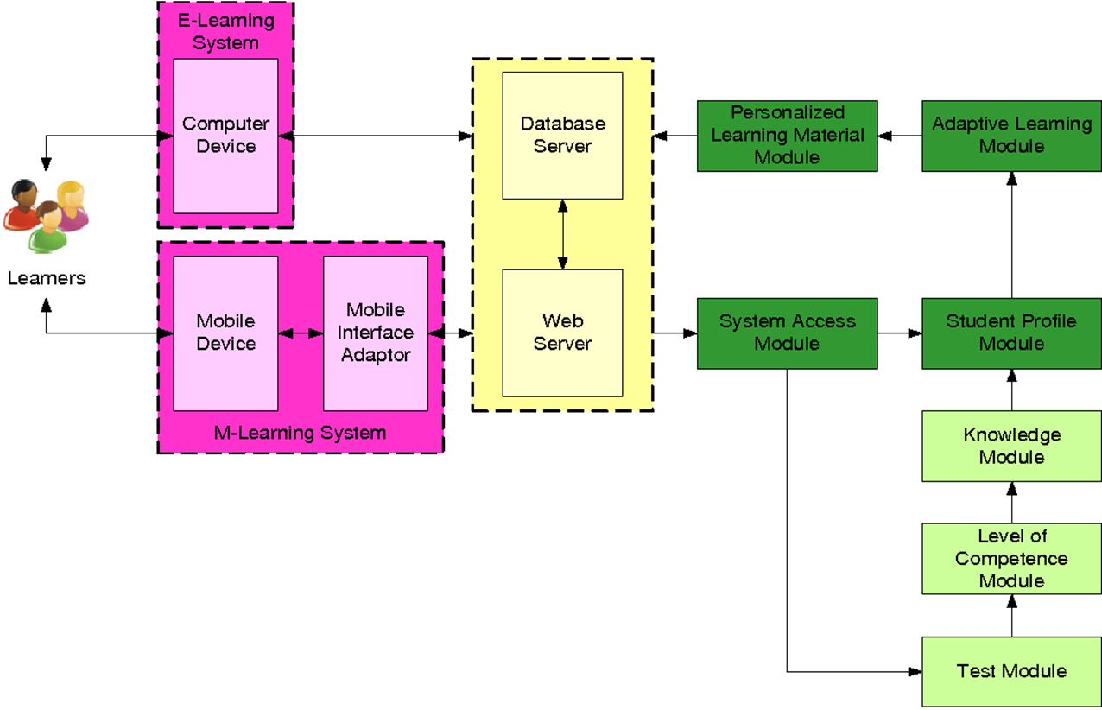
Flowchart:

Figure 6.2

CHAPTER 7
7.Project Scheduling
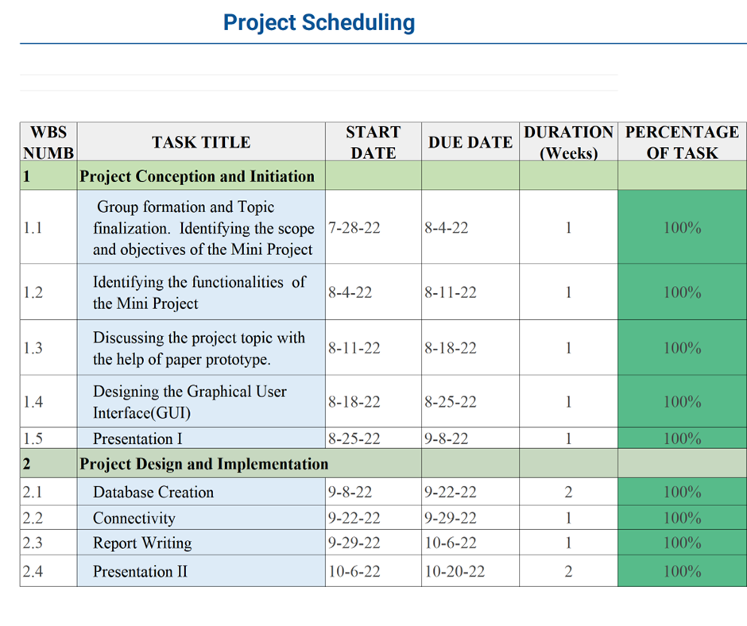
Figure 7.1

Chapter8
8.Conclusion:-
The project covers the successful development of a decent GUI slong with the Database Connectivity.
In conclusion, online learning is beneficial to the students, tutors and the institution offering these courses. I would therefore recommend that online learning be implemented on all learning institutions and research on how to improve this learning process should be carried out.

CHAPTER 9
REFERNCES:-
https://elearningindustry.com/
https://www.slideshare.net/
https://blog.commlabindia.com/
https://www.e-learningpartners.com/
https://community.articulate.com/
https://corp.kaltura.com/

